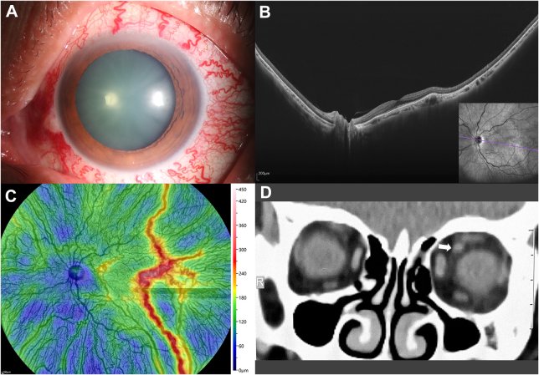

A 56-year-old woman presented with a 6-month history of painless redness in her left eye. Her vision was 20/25 with intraocularpressure of 15.7 mmHg, and without a history of trauma. Anterior segment with medical mydriasis showed dilated corkscrew episcleral andconjunctival vessels (A). Ultrawide-field OCT and angiography (BMizar, TowardPi Medical Technology) revealed a normal neuroretina,dilated and tortuous retinal veins, and corkscrew choroidal vessels resulting in an abnormal choroidal thickness map (B, C). Computedtomography confirmed a dilated superior ophthalmic vein (arrow) and thickened medial rectus (D). Based on the provided images and clinical description please make an ophthalmic diagnosis for this patient. And output the diagnostic conclusions only.

**Orbital venous congestion.**